
KRR ASSIGNMENT 1
PROGRAMMING ASSIGNMENT


ARHAM KHAN 22K-4080

PROBLEM 1: TOADS AND FROGS
Q1.PL
initial_state([t, t, 0, f, f]).
goal_state([f, f, 0, t, t]). % Goal state to achieve

move([t, 0 | Rest], [0, t | Rest], 'Toad Slide'). % Toad Slide to the right
move([t, f, 0 | Rest], [0, f, t | Rest], 'Toad Hop'). % Toad Hop over Frog

move([f, 0 | Rest], [0, f | Rest], 'Frog Slide'). % Frog Slide to the left
move([0, t, f | Rest], [f, t, 0 | Rest], 'Frog Hop'). % Frog Hop over Toad

% Handle move in the middle of the list
move([H | T], [H | T1], Move) :-
move(T, T1, Move). % Recursively apply move on the remaining part of the list

solve(State, Goal, _, []) :-
State = Goal. % Base case

solve(State, Goal, Visited, [MoveDesc | Moves]) :-
move(State, NextState, MoveDesc), % Find a valid move
\+ member(NextState, Visited), % Ensure this state hasn't been visited
solve(NextState, Goal, [NextState | Visited], Moves). % Continue solving from the new state

moves_of_toads_and_frogs :-
initial_state(StartState),
goal_state(GoalState),
solve(StartState, GoalState, [StartState], Moves),
write('Possible Set of Moves: '), nl, write(Moves), nl.

OUTPUT:
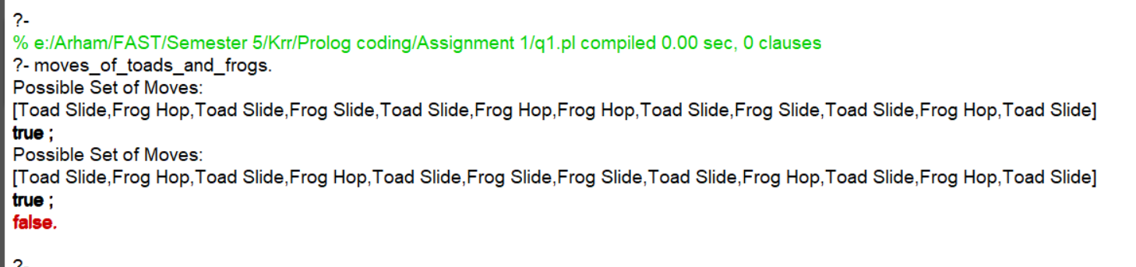
PROBLEM 2: ROUTES IN WONDERLAND
Q2.pl
route(a, b, 5).
route(b, c, 3).
route(a, d, 7).
route(d, c, 4).
route(c, e, 2).
route(e, f, 6).
route(b, e, 10).

% Direct route
path(X, Y, [X, Y], D) :- route(X, Y, D).

% Indirect route
path(X, Y, [X | Path], D) :-
route(X, Z, D1),
path(Z, Y, Path, D2),
D is D1 + D2.

format_route_with_distance([X], D) :-
write(X), write(' : '), write(D), nl.
format_route_with_distance([X, Y | Rest], D) :-
write(X), write(' -> '), format_route_with_distance([Y | Rest], D).

find_all_routes :-
write('All possible routes (direct and indirect) with distances:'), nl,
findall((Path, D), path(_, _, Path, D), AllPaths),
display_routes_with_distances(AllPaths).

display_routes_with_distances([]).
display_routes_with_distances([(Route, D) | Rest]) :-
format_route_with_distance(Route, D),
display_routes_with_distances(Rest).

% 2: Multi-hop routes
multi_hop_path(X, Y, K, [X, Y], D) :-
K =:= 1, route(X, Y, D).
multi_hop_path(X, Y, K, [X | Path], D) :-
K > 1,
route(X, Z, D1),
K1 is K - 1,
multi_hop_path(Z, Y, K1, Path, D2),
D is D1 + D2.

% 3: Longest route
longest_route(X, Y, LongestPath, LongestDistance) :-
findall((Path, D), path(X, Y, Path, D), AllRoutes),
find_longest(AllRoutes, LongestPath, LongestDistance).

find_longest([(Path, D)], Path, D).
find_longest([(Path, D) | Rest], LongestPath, LongestDistance) :-
find_longest(Rest, P, D2),
(D > D2 -> (LongestPath = Path, LongestDistance = D); (LongestPath = P, LongestDistance = D2)).

% 4: Routes with fixed distance
routes_with_distance(X, MaxD, Y, Path, D) :-
path(X, Y, Path, D),
D =< MaxD.

% 5: Multi-destination route
multi_destination_route([X, Y], [X, Y], D) :-
route(X, Y, D).
multi_destination_route([X, Y | Rest], [X | Path], D) :-
route(X, Y, D1),
multi_destination_route([Y | Rest], Path, D2),
D is D1 + D2.

% 6: Shortest paths between all points
shortest_path(X, Y, ShortestPath, D) :-
findall((Path, D1), path(X, Y, Path, D1), Distances),
find_shortest(Distances, ShortestPath, D).

% Find the shortest route in a list of paths
find_shortest([(Path, D)], Path, D).
find_shortest([(Path, D1) | Rest], ShortestPath, D) :-
find_shortest(Rest, P, D2),
(D1 < D2 -> (ShortestPath = Path, D = D1); (ShortestPath = P, D = D2)).

all_shortest_paths :-
findall((X, Y, ShortestPath, D), (route(X, _, _), route(Y, _, _), shortest_path(X, Y, ShortestPath, D)), ShortestPaths),
display_shortest_paths(ShortestPaths).

display_shortest_paths([]).
display_shortest_paths([(X, Y, ShortestPath, D) | Rest]) :-
write(X), write(' -> '), write(Y), write(' : '),
format_route_with_distance(ShortestPath, D),
display_shortest_paths(Rest).
OUTPUT (All direct and indirect routes):
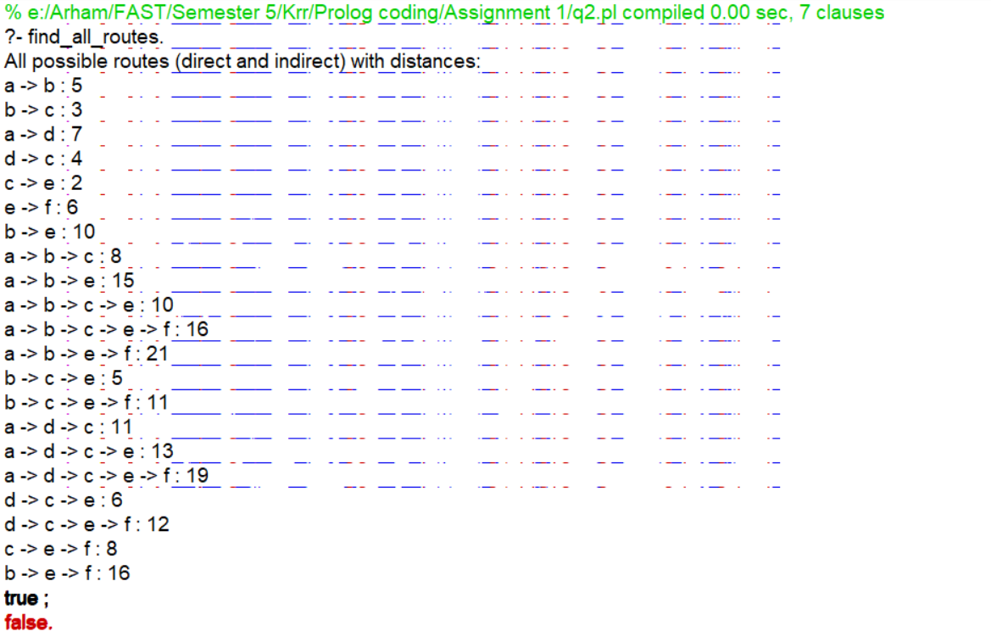

OUTPUT (Multi- hop Routes):
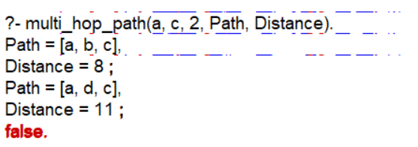

OUTPUT (Longest Route - direct):
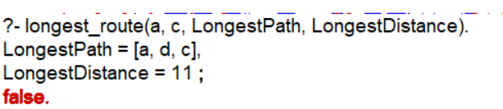

OUTPUT (Routes with Fixed Distance):
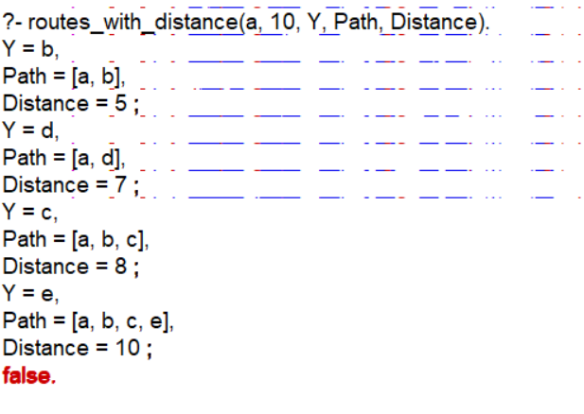
OUTPUT (Multi-Destination Route):
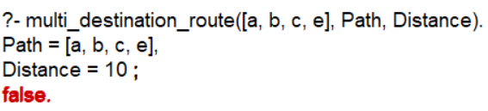

OUTPUT (All Shortest Paths):
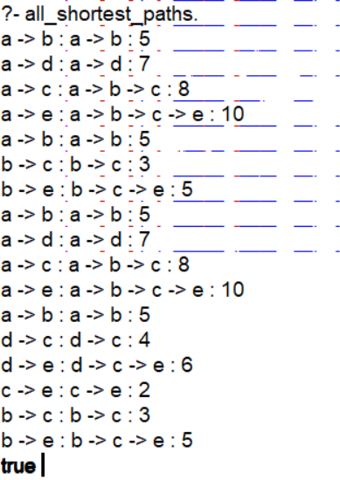

PROBLEM 3:

Q3.pl
% dynamic predicates
:- dynamic vertex/1.
:- dynamic edge/2.

% Load vertices and edges from a file
load_graph(File) :-
see(File),
repeat,
( read(Term),
( Term == end_of_file -> !;
assert(Term), fail
)
),
seen.

% BFS implementation
bfs(Start, Goal) :-
bfs([Start], Goal, []).

bfs([Goal | _], Goal, _) :-
write('Found: '), write(Goal), nl.
bfs([Current | Rest], Goal, Visited) :-
\+ member(Current, Visited), % Check if current node is already visited
write('Exploring: '), write(Current), nl,
findall(Next, (edge(Current, Next), \+ member(Next, Visited)), NextNodes),
write('Next nodes to explore: '), write(NextNodes), nl,
append(Rest, NextNodes, NewQueue),
bfs(NewQueue, Goal, [Current | Visited]).

% DFS implementation with unique output
dfs(Start, Goal) :-
dfs(Start, Goal, [Start], Path),
reverse(Path, FinalPath), % Reverse the path for correct order
write('Path: '), write(FinalPath), nl,
!. % Cut to prevent backtracking after finding the first path

dfs(Goal, Goal, Visited, Visited) :-
!. % Cut to avoid backtracking when goal is reached.
dfs(Current, Goal, Visited, Path) :-
edge(Current, Next),
\+ member(Next, Visited),
dfs(Next, Goal, [Next | Visited], Path).

% To run the search
search_graph(SearchType, Start, Goal) :-
SearchType = bfs -> bfs(Start, Goal);
SearchType = dfs -> dfs(Start, Goal);
write('Invalid search type.'), nl.

OUTPUT:

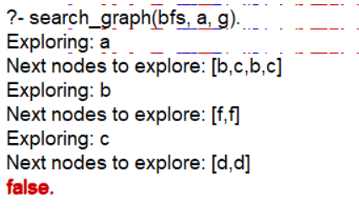
DFS:
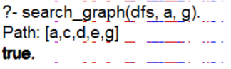

PROBLEM 4:
Q4.pl
% knight's jump
jump(X/Y, X1/Y1) :-
( DX is 2, DY is 1; DX is 1, DY is 2;
DX is -2, DY is 1; DX is -1, DY is 2;
DX is 2, DY is -1; DX is 1, DY is -2;
DX is -2, DY is -1; DX is -1, DY is -2
),
X1 is X + DX,
Y1 is Y + DY,
between(1, 8, X1),
between(1, 8, Y1).

% knightpath/1
knightpath([Start, End]) :-
jump(Start, End).

knightpath([Start, Next | Rest]) :-
jump(Start, Next),
knightpath([Next | Rest]).

% Find a knight's path of length 4 that goes through specific squares
find_knight_path(Path) :-
write('Possible Paths: '), nl,
length(Path, 5),
Path = [2/1, _, 5/4, _, End],
End = _/8,
knightpath(Path).

% To see all possible jumps from a square
find_jumps(Square) :-
findall(NewSquare, jump(Square, NewSquare), Jumps),
write('Possible jumps from '), write(Square), write(': '), write(Jumps), nl.

OUTPUT:
